**“IS 300 ENOUGH?” A PRACTICAL INSIGHT INTO AORTIC ROOT VENTING AND EFFECTIVE DE-AIRING.**

Nicholas Trafford *(DSci, ACP, LCCP)* - Essex Cardio-Thoracic Centre

**Background:**

Gaseous macro-embolism during open heart surgery is a known risk and one that can be minimised yet never fully avoided. Embolic events are strongly linked to end-organ ischemia and postoperative neurological complications, such as cerebral injury, CVA and TIA, and possible myocardial dysfunction and dysrhythmias.

Effective de-airing techniques are crucial in removing gaseous emboli, both micro and macro, from the heart and aorta during and after closure of the myocardium and/or great vessels. There is no standardised approach and ambiguity exists within the surgical community over which techniques are more effective. Techniques deployed are wholly centred on venting via the aortic root and/or superior pulmonary vein/left ventricular vent. The effectiveness of these venting sites are dependent on variable factors such as vent flow, patient positioning, systemic pressures and flow output during cardio-pulmonary bypass (CPB) along with carbon dioxide insufflation.

The vent rate of 300mls/min is often used when de-airing the heart from the aortic root, and is often the preferred rate by many surgeons, yet the clinical reasoning behind this value is somewhat unsubstantiated with limited supporting evidence. The aim of this study is to assess the efficacy of different vent flows at set flow outputs and to what extent Trendelenburg positioning affects the de-airing process.

**Method:**

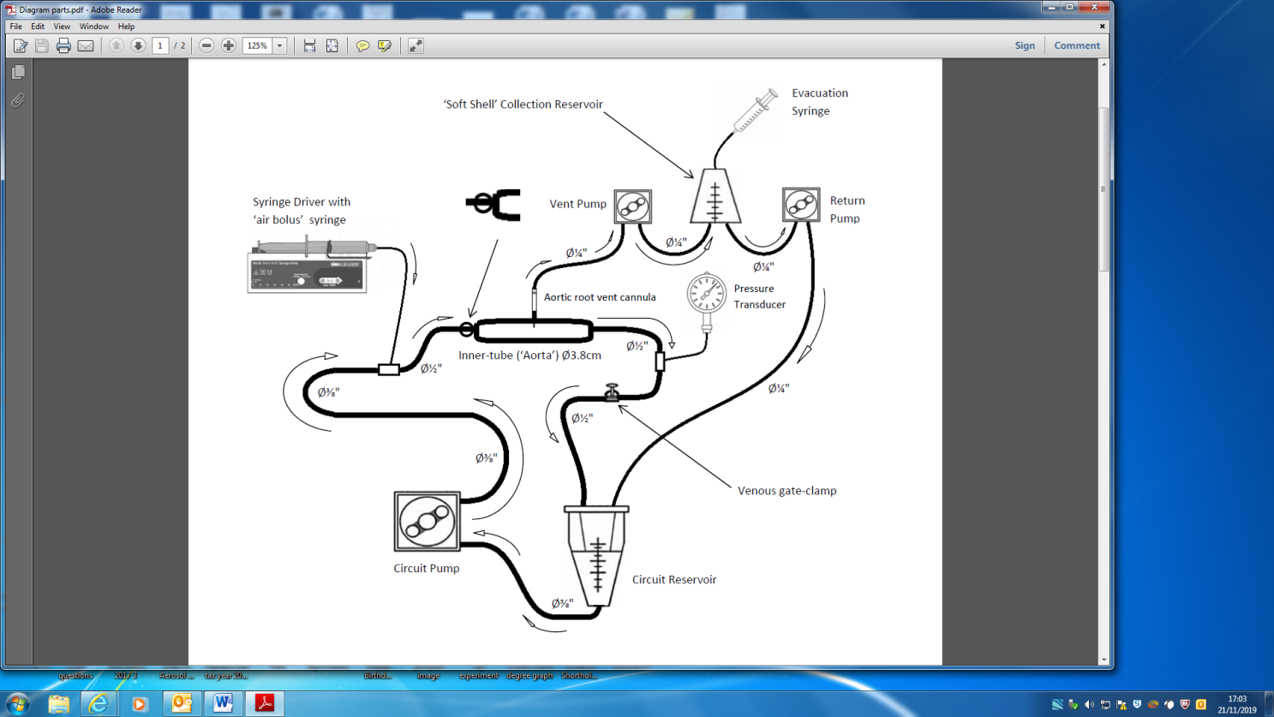A ‘Doppler Test Fluid’ primed circuit to simulate the de-airing process was constructed using components of a bypass circuit including a reservoir and silicone pump boot. The aorta was simulated using an inner tube measuring 4cm in diameter that provided similar compliance, diameter and wall thickness of that of the aortic root.

A ‘non-vented’ aortic root cannula was inserted at the highest point of the inner tube for de-airing. A venous gate clamp was used to allow sufficient control to occlude the circuit return, so line pressures could be maintained at 100mmHg throughout.

Pressure and flow were generated using a roller pump, set at 3, 4 and 5 litre per minute flow.

Macro emboli within the aorta were simulated using a set of syringe drivers, delivering set volumes of air into circuit, ranging from 20mls to 70mls at fixed rates (10ml/s).

Air was evacuated via the root vent and could be captured in a separate ‘soft shell’ reservoir. The air evacuated could be offset from the volumes of air injected into the circuit at different flows.

The inner-tube position could be manipulated into a 20° angle to simulate Trendelenburg positioning (head down)

Results could be collated running variable flows (3, 4 and 5 litres/min), variable vent flow rates from 200ml-500ml/min and variable air bolus volumes ranging from 20ml-70ml, given at 10ml/s.

**Results:**

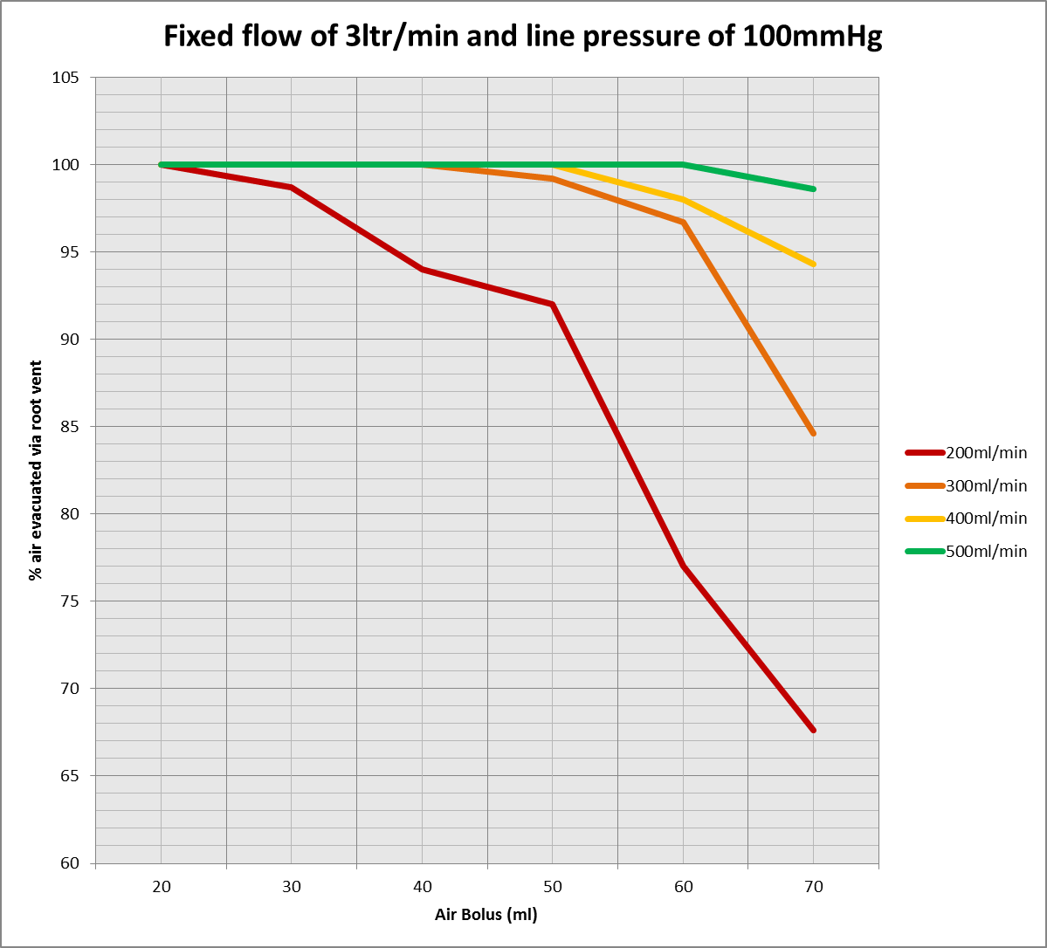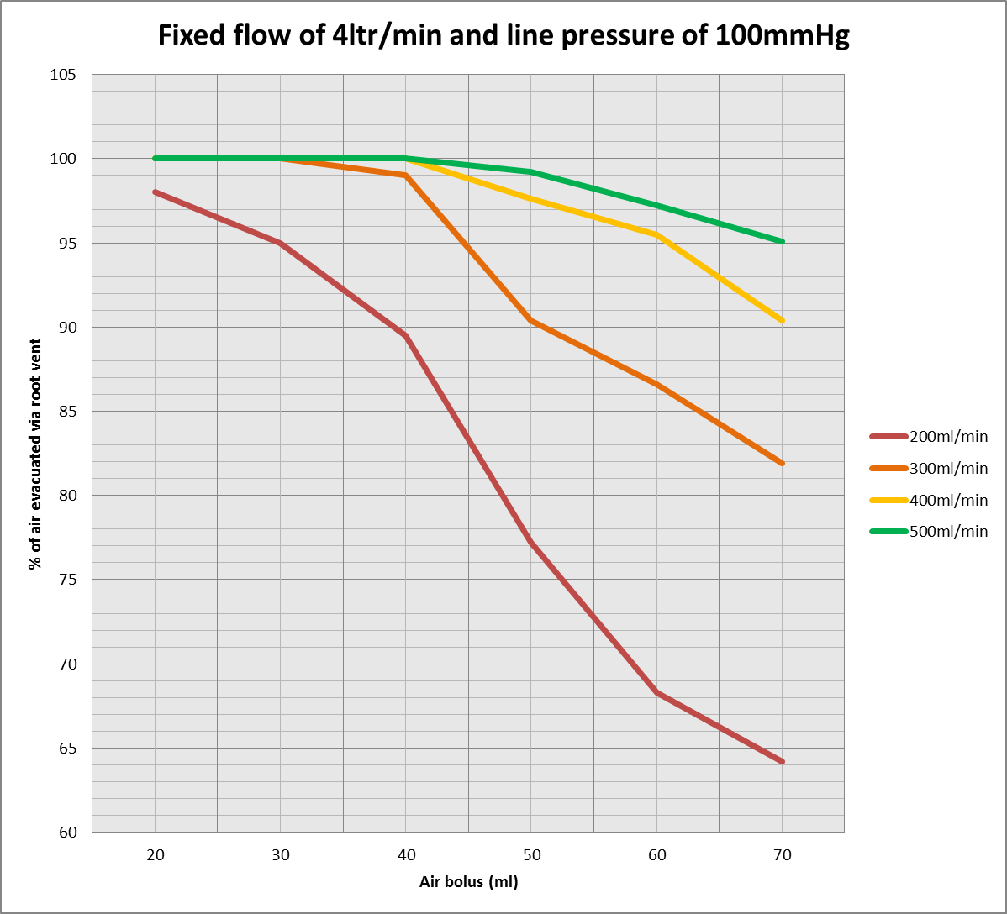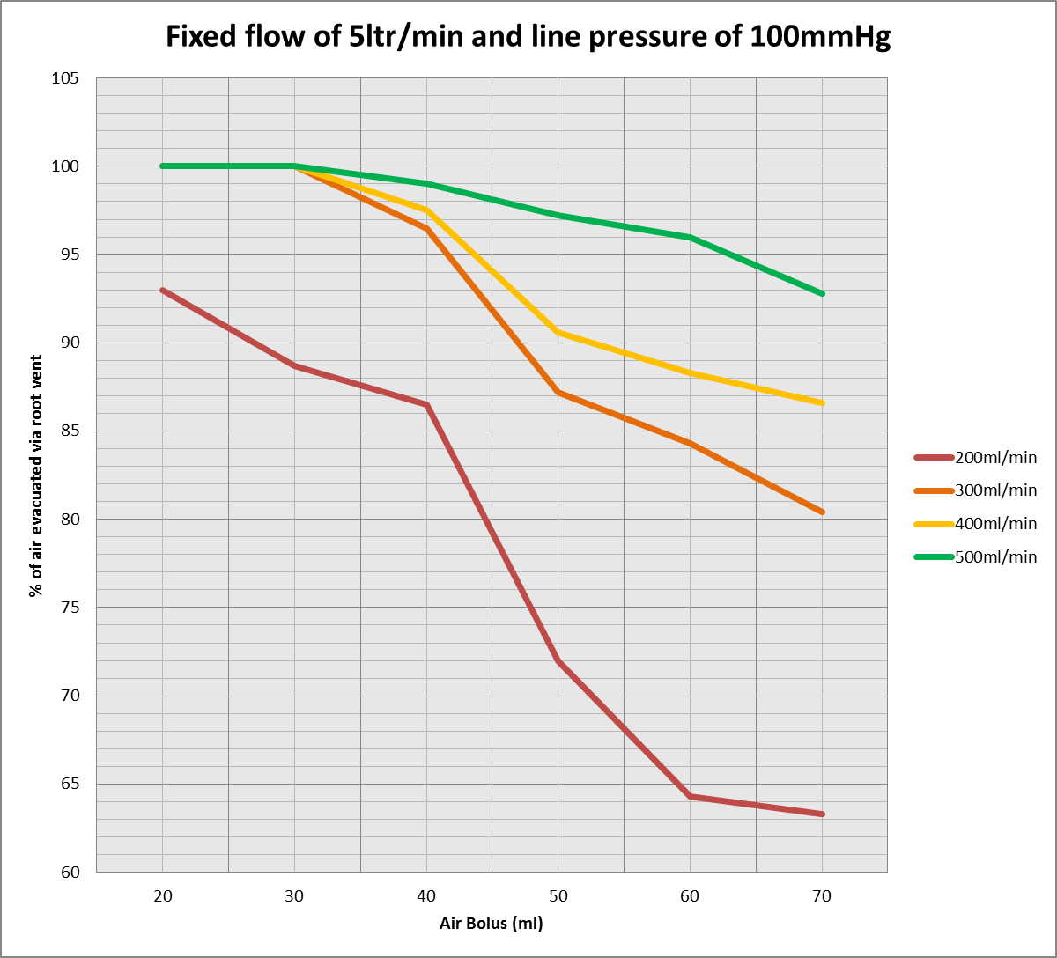

There was a significant correlation between vent efficiency when using higher vent flow rates at lower flow outputs. Venting at 500ml/min was effective in removing 92.8% of air at 5ltr/min flow, compared to 63.3% of air when venting at 200ml/min. Venting efficacy improved when flow output was reduced.

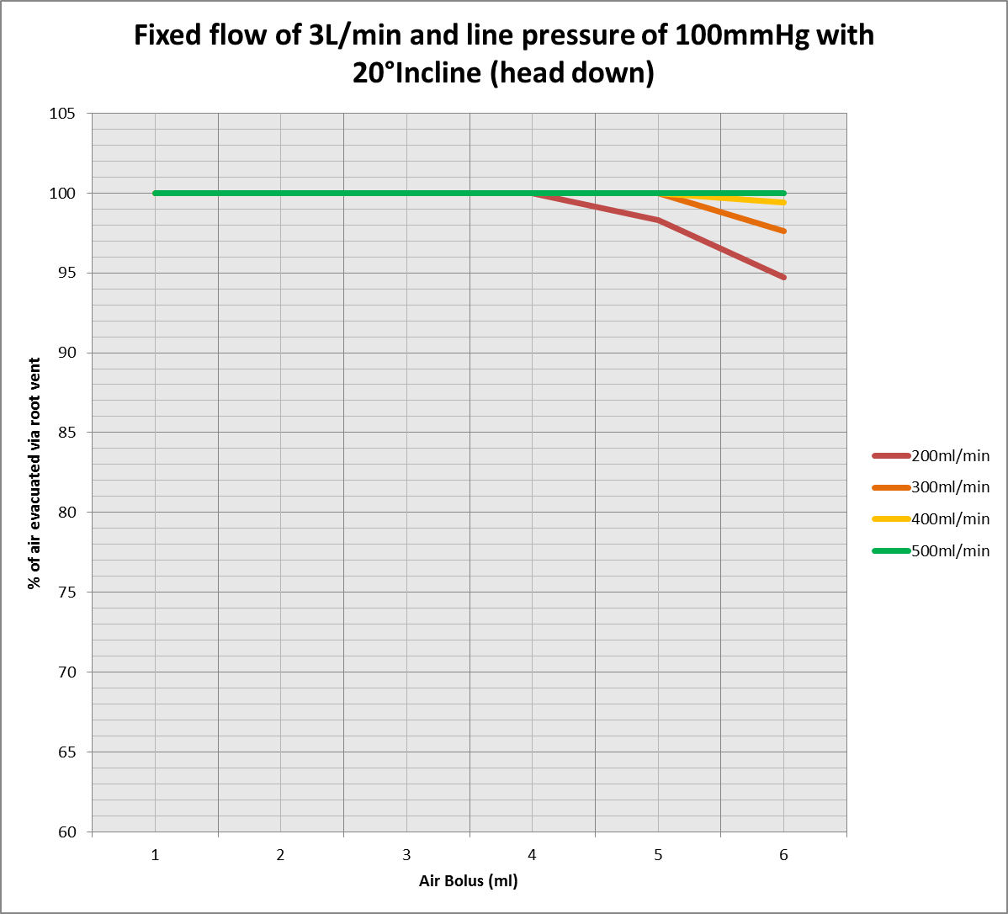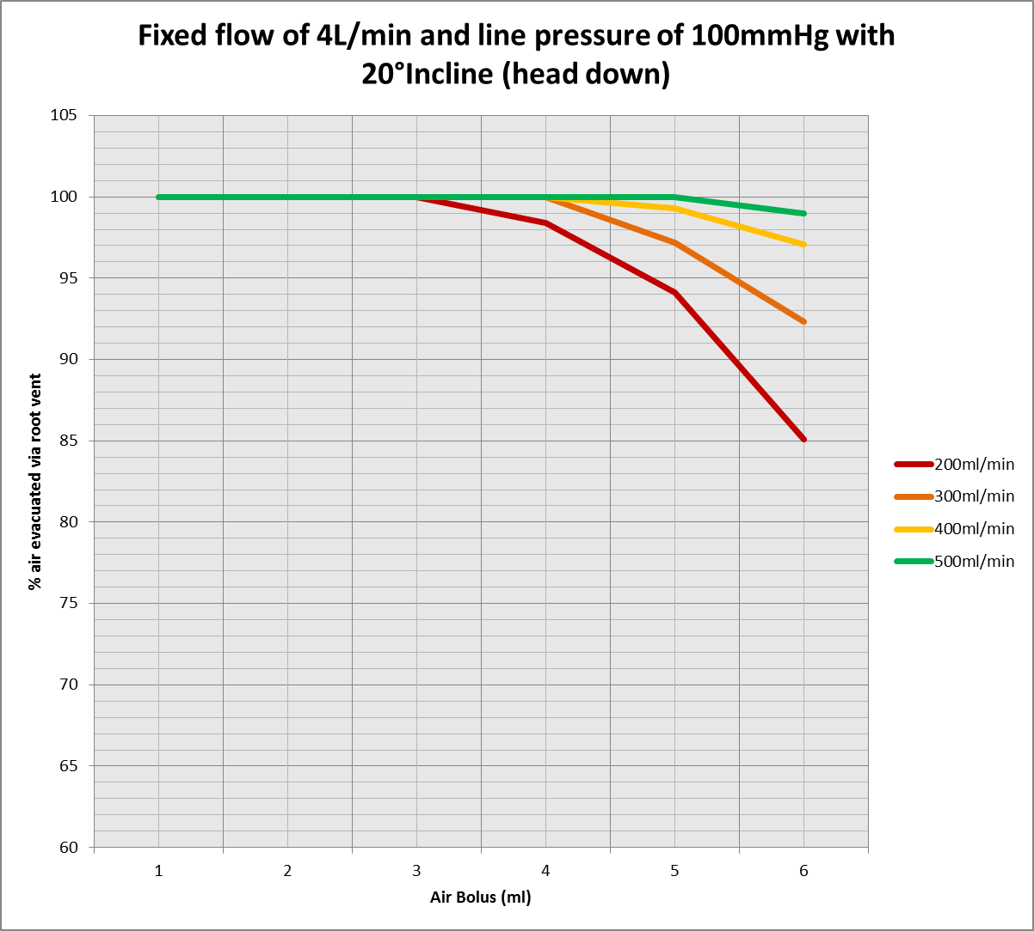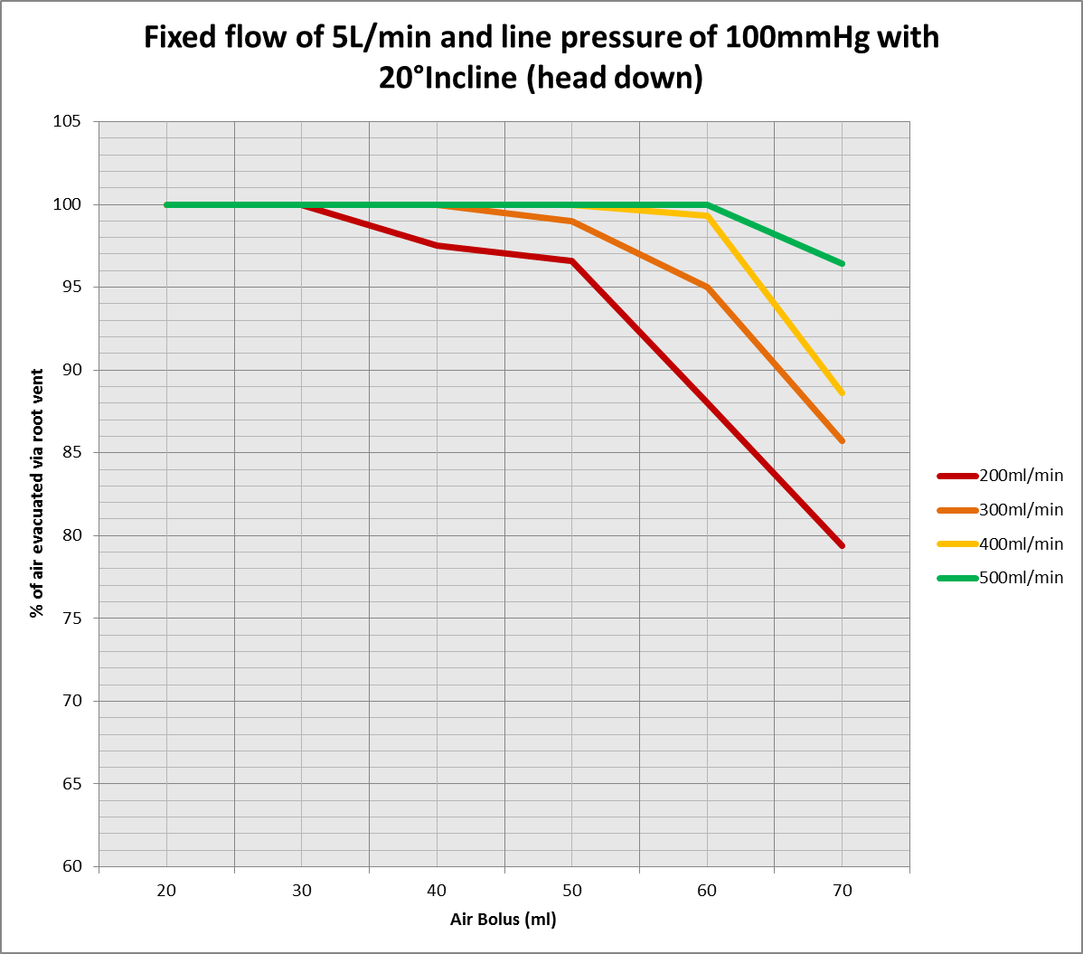

When a 20° incline was applied, venting efficacy improved across all parameters, more so at lower vent flow rates. Venting at 300ml/min at 5ltrs/min flow output saw an average increase of 5.3% in air evacuation when the largest air bolus (70ml) was delivered.

**Conclusion:**

Venting at higher flow rates does show an improvement in gaseous evacuation. However there needs to be an appreciation that when venting at higher rates, this will diminish patient systemic flow and increase haemolysis during cardio-pulmonary bypass.

Provisional results imply that effective vent flow should be proportional to the patient flow and therefore be increased in patients with higher body surface areas and resultant higher flows. Based on the pilot study, an initial hypothesis can be drawn which infers that the vent rate should be 10% of the patient flow rate.

Though the results strongly suggest that inverted patient positioning and aortic manipulation significantly improves aortic root de-airing efficiency, the caveat is that the modelling lacks sophistication. An immediate limitation is the simulation of complex fluid dynamics seen during bypass, as this model study looks purely at aspects of de-airing from a unidirectional flow of gaseous macro-emboli in fluid. In reality, the flow would be multidirectional, due to the position of the aortic cannula and the subsequent retrograde flow of blood towards the heart, which would dramatically alter the dynamics of gaseous emboli entering the aortic root. More advanced modelling would be required to simulate such dynamics.